**ASSIGNMENT – 3**

NAME : KANISKA VARSINI P D

ROLL.NO: 718019Z222

TEAM ID : PNT2022TMID12518

PROJECT : NUTRITION ASSISTANT APPLICATION

1.Create a Bucket in IBM object storage.

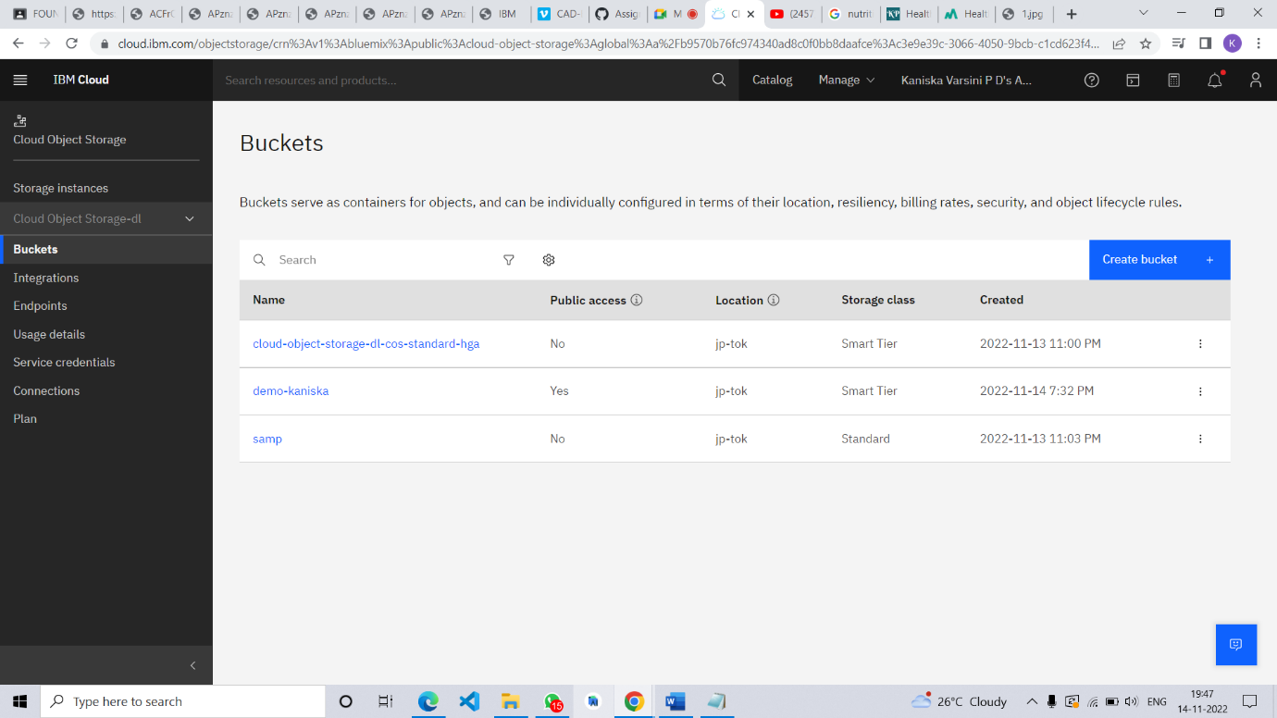

2.Upload an 5 images to ibm object storage and make it public.

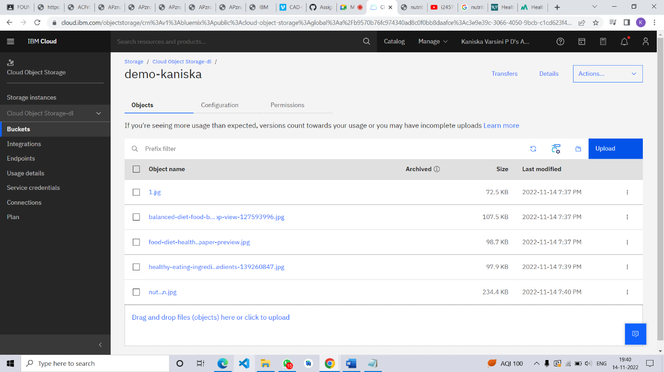



write html code to displaying all the 5 images.

<!DOCTYPE html>

<html lang="en">

<head>

    <meta charset = "UTF-8">

    <meta http-equiv="X-UA-Compatible" content="IE=edge">

    <meta name="viewpoint" content="width=device-width , initial-scale=1.0">

    <title>IBM Cloud Storage Images</title>

    <link rel="stylesheet" href="mystyle.css">

</head>

<body>

<img src="./1.jpg" >

<img src="./balanced-diet-food-background-healthy-ingredients-dark-bac-fruits-vegetables-meat-cereals-nuts-top-view-127593996.jpg" >

<img src="./food-diet-healthy-fresh-wallpaper-preview.jpg" >

<img src="./healthy-eating-ingredients-fresh-vegetables-fruits-superfood-nutrition-diet-vegan-food-concept-healthy-eating-ingredients-139260847.jpg" >

<img src="./nutrition.jpg" >

</body>

</html>

3.Upload a css page to the object storage and use the same page in your HTML code.

html{

    background-color: rgb(246, 245, 245);

 }

 body {

    display: flex;

    flex-wrap: wrap;

    gap: 100px;

    justify-content: center;

    align-items: center;

 }

 img {

    width: 25%;

 }

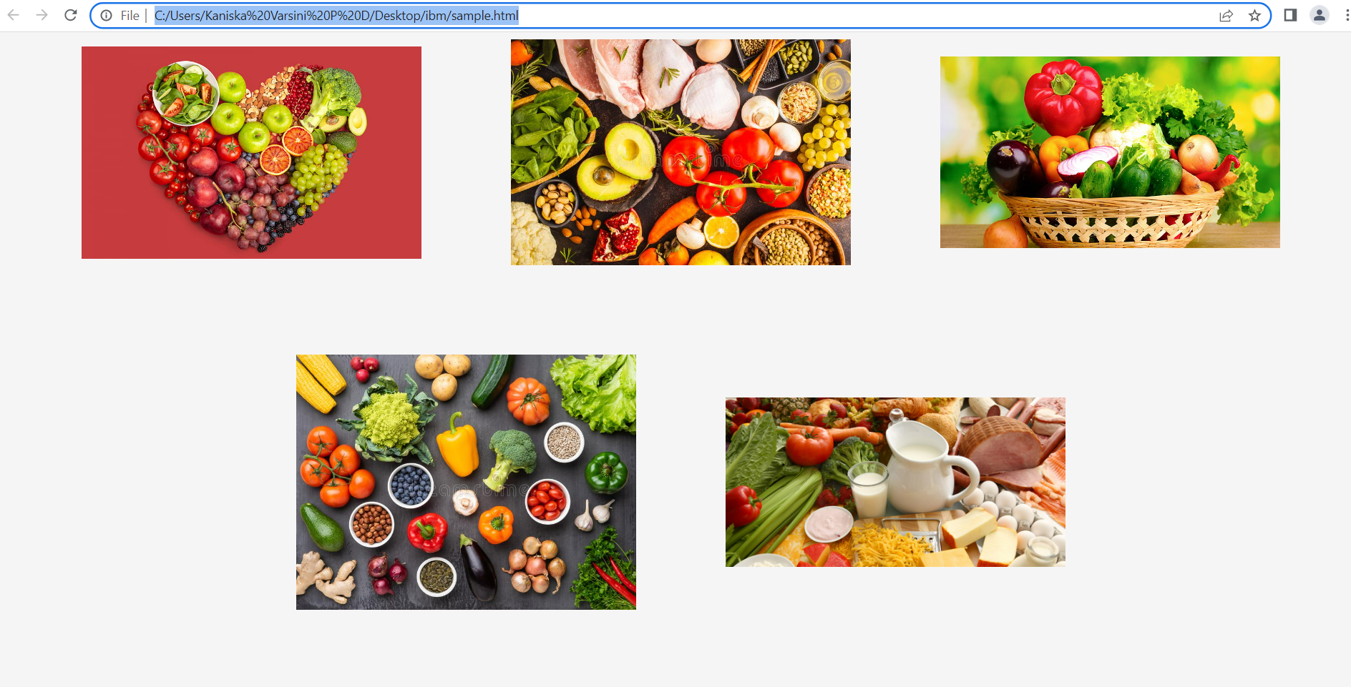

4.Design a chatbot using IBM Watson assistant for hospital.

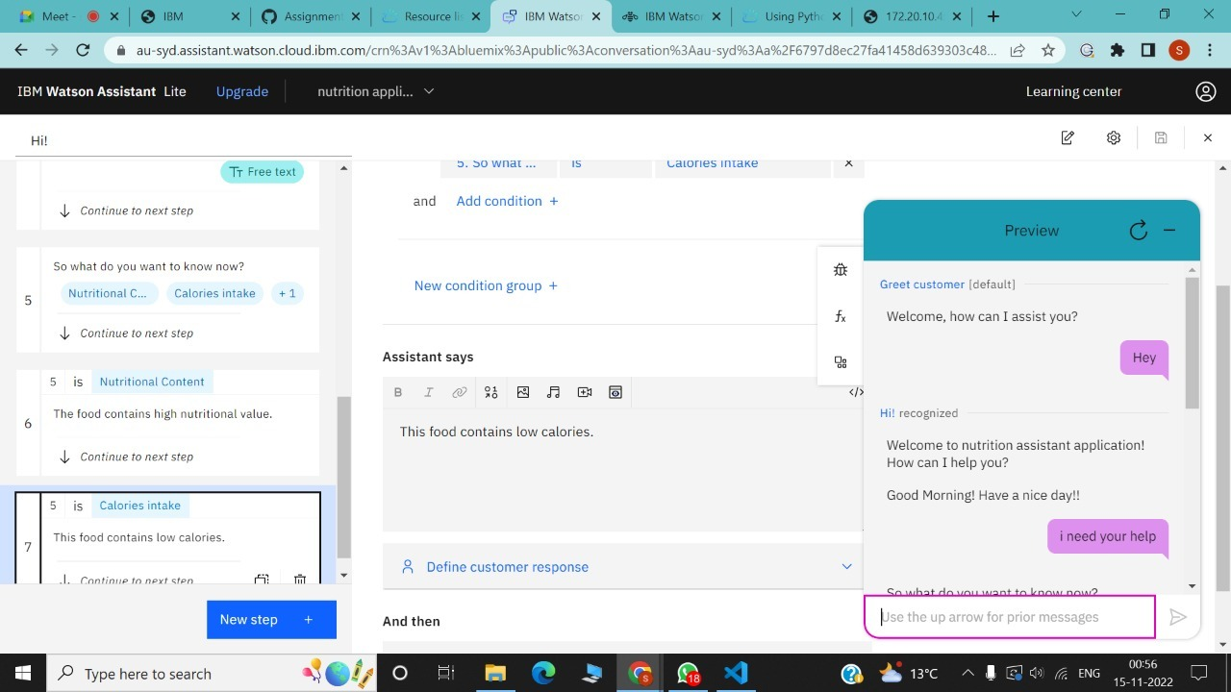

5.Create Watson assistant service with 10 steps and use 3 conditions in it. Load that script in HTML page.

